Certificate: Information Technology: Systems Development (Web Development 2)

PROGRAMMING (GPG522)

Project 3

Theme:

Hand out: 10/18/2018

Hand in: 10/26/2018

Section A [9]

Select from list

Question 1 [5]

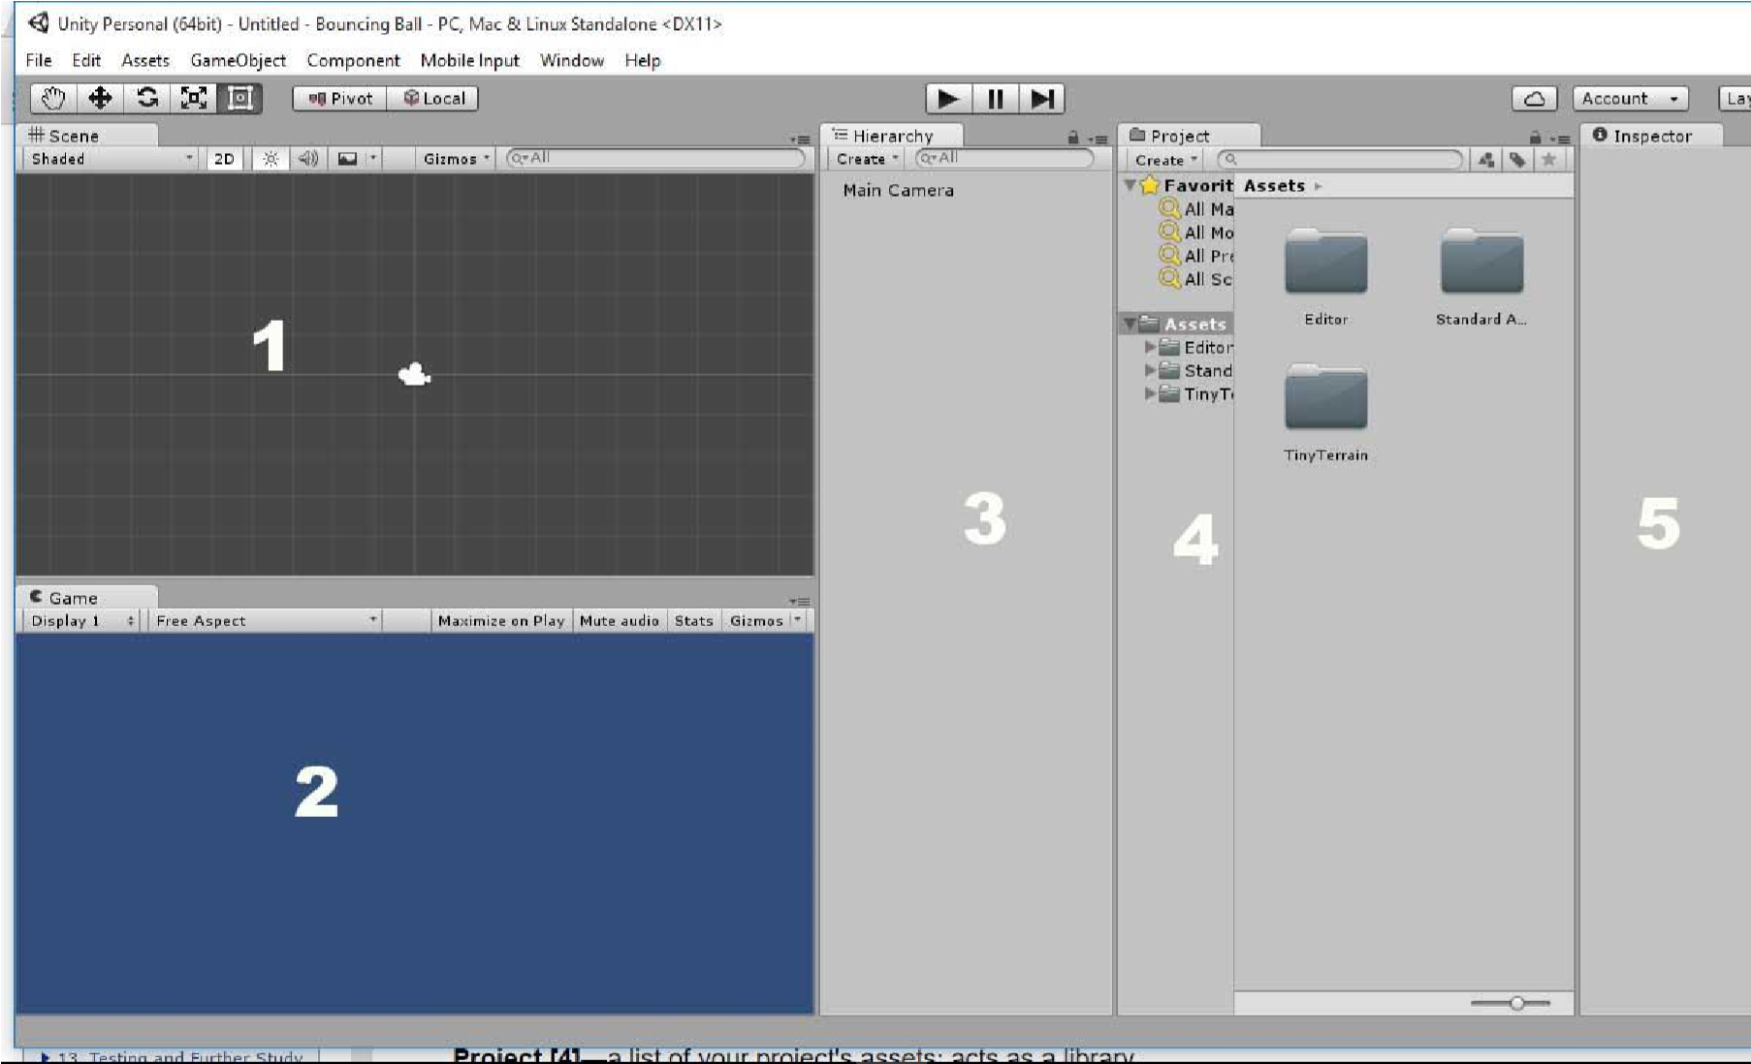

Given the diagram above, identify the numbered labels above.

1. ___________Scene______
2. ______Game__________
3. _____hierarchy________________
4. _________project__________
5. __________Inspector___________

Question 2 [4]



Identify the symbols in the diagram above

* 1. ______Hand tool_____
  2. _____translate tool_______
  3. _____Rotatate tool_______
  4. _____Scale tool______

Section B[65]

Long questions

Question 1[5]

Differentiate between local space and world space.

Question 2[5]

An object A in the game world is located at the coordinate (4, 5). It then moves (7,4) relative to its original position. Showing your calculations, what position is object A?

Question 3[20]

Define the following

* Assets:
* Prefabs:
* Scripts:
* Collider:
* Scenes:
* Components:

Question 4[5]

**Is there any performance considerations to using a GUI?**

Question 5[5]

**How many objects of a prefab can exist in a scene?**

Question 6[5]

If you want to illuminate an entire scene with one light, which type should you use?

Question 7[5]

How many user defined layers can you have?

Question 8[5]

What property determines which layers are ignored by lights and cameras?

Question 9[5]

Explain the difference between Unity and Unreal Engine?

Question 10[5]

Explain why vectors should be normalized when used to move an object.

Section C [26]

Practical

1. Create a new scene or project. Add a sphere to the scene and place it at (0, 0, 0).
2. Add four point lights to your scene. Place them at (-4, 0, 0), (4, 0, 0), (0, 0, -4), and (0, 0, 4). Give each of them their own colour. Set the ranges and intensities how you would like to create a visual effect on the sphere that you find enjoyable.
3. Delete the main camera from your scene (right click the main camera and select “**Delete**”). Add four cameras to the scene. Disable the audio listener on three of them. Position them at (2, 0, 0), (-2, 0, 0), (0, 0, 2), and (0, 0, -2). Rotate each of them about the y axis until they are facing the sphere.
4. Change the view port settings on the four cameras so that you achieve a split screen effect with all four cameras. You should have a camera displaying in each corner of the screen taking up a quarter of the screen’s size (see Figure)

